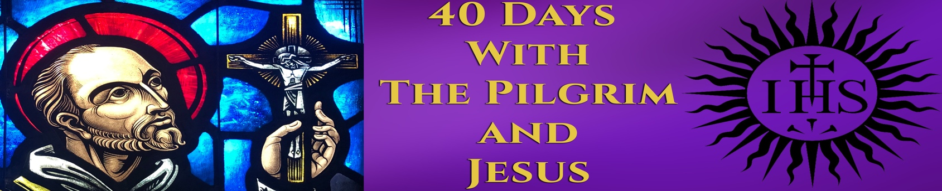

ANIMA CHRISTI prayer
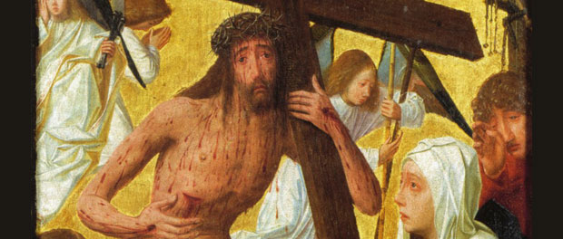

Soul of Christ, sanctify me.
Body of Christ, save me.
Blood of Christ, inebriate me.
Water from the side of Christ, wash me.
Passion of Christ, strengthen me.
O Good Jesus, hear me.
Within your wounds hide me.
Permit me not to be separated from you.
From the wicked foe, defend me.
At the hour of my death, call me
and bid me come to you
That with your saints I may praise you
For ever and ever. Amen.

PRAYER OF TEILHARD DE CHARDIN SJ
Above all, trust in the slow work of God.
We are quite naturally impatient in everything to reach the end without delay.
We should like to skip the intermediate stages.
We are impatient of being on the way to something unknown, something new.
And yet it is the law of all progress
that it is made by passing through some stages of instability—
and that it may take a very long time.
And so I think it is with you;
your ideas mature gradually—let them grow,
let them shape themselves, without undue haste.
Don’t try to force them on,
as though you could be today what time
(that is to say, grace and circumstances acting on your own good will)
will make of you tomorrow.
Only God could say what this new spirit
gradually forming within you will be.
Give Our Lord the benefit of believing
that his hand is leading you,
and accept the anxiety of feeling yourself
in suspense and incomplete.
—Pierre Teilhard de Chardin, SJ

40 Days with the Pilgrim and Jesus

2/19/21 HANDOUT

Searching for Beauty in the Age of Instagram
Erika Rasmussen
America Magazine
A few weeks ago, my mom came back from a trip to Moab, Utah, bearing gifts: a miniature orange buffalo made of calcite, a flamingo-pink ball cap and a half-dollar-sized hunk of fool’s gold. My family chatted around the dinner table as I rolled the cool rock around in my palm, new hat on head, letting it glint in the kitchen light. “Man, this thing should be beautiful to me,” I thought to myself. A hundred little surfaces winked gold, shadow, gleam.
And it was beautiful—but somehow it also wasn’t. Because, since my toddler days, I have lived and moved in a world where fake rubies adorn fuzzy dress-up gear, where the gift shop at the Denver Museum of Nature and Science lets you snap up crystals like they were Cracker Jacks and where I can buy myself a pair of 18-karat gold-filled earrings for $50.
An alarm sounded: Beauty isn’t dawning on me like it should. There was something beautiful in front of me, but somehow the beauty itself wasn’t registering. It didn’t make me feel a thing. Have I been desensitized? If beauty reveals, as Hans Urs von Balthasar wrote, “the truth and goodness of the depths of reality,” am I a welcoming host to its revelation?
At the same time I haven’t been recognizing beauty every time it is before me, I also haven’t been recognizing God. What if those disconnects are related?
In a society driven by productivity and immersed in overstimulating environments, where social media has actually programmed us to ignore inflections of beauty because they’re “just another pretty picture” or song or face, we have become numb to the constant beauty that is unfolding God before us. But beauty speaks. As with beauty, God is. God unfolds. God gives the breath, and God takes it away.
Early in 2020, before the pandemic hit, I spoke with a Carmelite named Sister Maura. Her monastery sits a mile down Benton Street from Santa Clara University. Visitors can walk next to an olive grove, among redwoods and roses and wisteria. At a certain point, I was walking there nearly every day to taste the peace. I wanted to learn about this sanctuary for the final project of my senior seminar, in which we were studying the rhetoric of place. I focused on the idea of history and how commemorative plaques form collective memory—everything (everything) communicates.
When I asked Sister Maura how she thought the monastery’s space communicated rhetorically, she told me: “It all points to God.” All the rooms carry stark simplicity, she explained: white walls, wooden crucifix. There are no distractions, she was saying. All God.
It made me think about the beauty of a simple line—the meeting of three walls at the corner of a room. Trinity. What points to God, and how we might be missing it.
The internet has become a sort of distribution center, especially for the visual. I might not bat an eye at a photo of a green-eyed Himalayan snow creature, or at the jade-water mountainscapes of Thailand—exquisite—because since I was 15 I have used phones that have tossed photos of impossible, faraway things at me daily. Instagram, Pinterest, Twitter, Tumblr, not to mention Hallmark cards, billboards, TV; there are calendar stores full of these images.
I can capture every spectacular moment of life on my iPhone—a beautiful reproduction or object around every corner, on every visit to social media, slapped on what seems like every surface imaginable. The saturation makes me feel like the full force of beauty itself is being subdued; like I’m becoming desensitized. I’m being programmed to scroll right past it.
I don’t think life was always this overstimulating, and the overstimulation has something to do with influx. The advent of manufacturing in the late 1700s in Europe, and then the invention of lithography in 1796, made printed art mass-producible. In the United States between 1870 and World War I, factories of the second industrial revolution began to streamline on-demand beauty. For the first time fabricated splendor became available to the masses: sets of china that didn’t cost a fortune, rhinestones that lit up the human body (with no need to dig into the earth to bring forth that precious glimmer).
This revolution democratized certain forms of beauty, yes—very good—but it may have also taken away a certain sense of beauty’s novelty; its shock value, its grab-you-by-the-shoulders lightning bolt of awe. Now, over a century later, I possess and see so much beautiful stuff that much of its frank, intrinsic beauty is somewhat lost on me. Sensation dwindles. Not because these things aren’t beautiful, but because I’ve been around these lovely things so much I don’t always bother to pay attention.
And for many of us in this pandemic, our immediate walls and ecosystem have become the world. Our screen time skyrockets. As March stretched into April and leaped into summer and fall, my iPhone so kindly notified me every week of the growing minutes I was spending glued to the screen. If I was addicted to Instagram before, now I’m really in deep.
Our phones connect us to one another and the world in profoundly vital ways moment to moment; but the intimacy we share with these rectangles of light toys with our energy, health and attentiveness! It is light, and it can bring us a timeline of delight (or misery). But we are letting beauty elude us. The extraordinary has become humdrum.
And in the thick of this disease, of viral chaos and isolation, our bodies are craving the intimacy of beauty, whether we know it or not. We probably crave beauty because we crave God, and beauty reveals something of God. Especially in these trying times, our need and desire for God’s love might be laid bare, if it wasn’t obvious before.
I am sure many of us may have, in different moments during these months, been brought to our wit’s end. We need God deeply, and so we need beauty deeply, too. Do we perceive every ounce of it, the beauty that hangs so delicately and intimately on each quark of this little universe?
In Heaven and Hell, Aldous Huxley writes that “modern technology has had the same devaluating effect on glass and polished metal as it has had on fairy lamps and pure, bright colours.” Huxley cites John of Patmos, who is possibly the author of the Book of Revelation. He writes: for “John of Patmos and his contemporaries walls of glass were conceivable only in the New Jerusalem.” A “glut” of glass and metal, Huxley calls it: “surfaces [that] wink at us in the bathroom, shine from the kitchen sink, go glittering across country in cars and trams.”
There are some days I want to sweep all my belongings into trash bags, scour my shelves and walls of all things thing until there’s nothing left but me and bare walls, bare wood. All I want is God—the good and the true and the beautiful. This “glut” of modern lifestyle just might subdue my intimacy with the truth of being itself.
An artist who renders a still life has always reminded us that the bare, everyday bits of life are lifegiving. Transcendent. God the Beautiful is in communion with the present world.
In her poem “Evidence,” Mary Oliver writes:
Beauty without purpose is beauty without virtue. But
all beautiful things, inherently, have this function—
to excite the viewers toward sublime thought. Glory
to the world, that good teacher.
Are we wholly allowing the world to be that good teacher?
St. Ignatius Loyola dug into the constant presence of God. Different versions of his Daily Examen prayer exercise instruct us to look back on our day with careful, God-seeking vision. We ask for the ability to notice God’s presence in each moment; we give thanks for particular experiences of the day and then look back on them to see where God was. Finally, we seek forgiveness for those times we failed to love, and we close with a petition for grace to fill tomorrow. This prayer and intention is also beauty-seeking vision. Asking to see where God is revealed might be the same as asking to notice the beautiful. And beauty arrives. Constantly.
I am most thankful these days for the sunlight that shines out of gasoline puddles and skyscrapers alike; the pudgy shuffling of dachshunds on tiny, perfect legs; the laughter of a stranger (or a roommate, through the wall) that has nothing to do with me but beats its wings between us anyway to sit in my chest; the creature of my body that does exactly what it pleases when a good song plays—any good song, any sort of good; the playground of shadows that comes out at night, when Thomas Edison keeps us awake and looking.
Poetry, prayer, mindfulness and art all have something in common. They can defamiliarize the reality that unfolds before us, make experience spring up anew. Some things that have gone numb need a good dose of resurrection. This includes the moment. When we pray, we see things as if for the first time. When we notice what’s right there in the moment, it is God.
In “Of Nicolette,” the poet E. E. Cummings presents the lily in soft glory:
a Winged Passion woke and one by one
there fell upon the night,like angel's tears,
the syllables of that mysterious prayer,
and as an opening lily drowsy-fair
(when from her couch of poppy petals peers
the sleepy morning) gently draws apart
her curtains,and lays bare her trembling heart
Poets most simply notice. Everyone has this power. Our daily life can rise up in “syllables” of “mysterious prayer” if we take the time to revel and stew in it. Ross Gay offers an embodied sort of prayer in “becoming a horse”:
It was
touching my nose to his made me know
the clover’s bloom, my wet eye to his
made me know the long field’s secrets.
Life is calling us to touch our noses to the moment, fix our wet eyes to whatever hint of heaven may be present. How can we, in this saturated society, craft our lives and cultivate our psyches to realize the beauty present there, in a way that opens us further to grace?
On a recent trip to Albany, N.Y., with a video team to film a short documentary, I was pulled back into the world of photography in which I grew up. My mother is a photographer and an artist, and much of my childhood was spent in front of the camera or fingering through photographs of water lilies and cathedrals—faces and landforms from a lifestyle of overseas travel and Colorado living.
I wasn’t that into it as a kid. But being handed a fancy camera again this past year, as I entered my 23rd year of life, has been like being handed new eyes. The viewfinder and process of capturing a particular moment in eternity opens up this posture of looking—of surrender to the beautiful—that is possible and present in every direction if we take the time to reframe ourselves.
As Richard Powers writes in The Overstory, “The only dependable things are humility and looking.” Most of what a camera does is what eyes do—what consciousness does. “Looking” in the way of seeking. Noticing. Focusing. Click.
Can touch be beautiful? Have you ever felt your own skin? And the sound of cars beating like waves down the highway. A spring rain in the nostrils. You know! The glide of water across our hands and backs—water, our birthplace. Water! That glossy little mango sitting on your table, that never-ending lineup of windows that bend light across the entire town to get to you, that stupid hunk of fool’s gold that now follows you around like a kid that won’t stop nagging, Look! Where is the beauty in it? Where? Where?
I want God. I want every reflection. If I were a minimalist; if I kept clicking the red X over the Instagram app forever; if I closed my eyes a bit more often and asked that opening them would bring revelation; if I wrote a poem every day; if all that was left on my walls was the engraving of clay hands reaching for the sun that hangs there now; then, might the beauty of both earth-made and human-made creation—line, color, wave—spur me into greater awareness of God as God, God as love, God as life itself?

WEEK ONE HANDOUTS

- SAINT IGNATIUS OF LOYOLA’S STORY
- WHAT ARE THE SPIRITUAL EXERCISES OF ST IGNATIUS?
- THE FIRST PRINCIPLE AND FOUNDATION
- PRAYER IS A CONVERSATION
- PRAYER IN THE SPIRITUAL EXERCISES
- THE IGNATIAN EXAMEN
- PREPARING FOR THE RETREAT
- 1ST WEEK OF PRAYER: GRATITUDE FOR GOD’S UNCONDITIONAL LOVE FOR ME

Saint Ignatius of Loyola’s Story
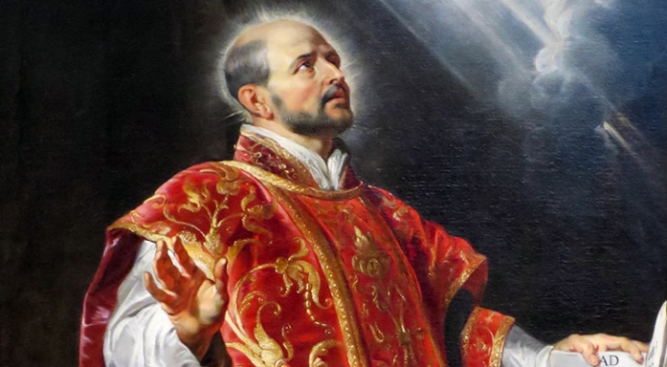
The founder of the Jesuits was on his way to military fame and fortune when a cannon ball shattered his leg. Because there were no books of romance on hand during his convalescence, Ignatius whiled away the time reading a life of Christ and lives of the saints. His conscience was deeply touched, and a long, painful turning to Christ began. Having seen the Mother of God in a vision, he made a pilgrimage to her shrine at Montserrat near Barcelona. He remained for almost a year at nearby Manresa, sometimes with the Dominicans, sometimes in a pauper’s hospice, often in a cave in the hills praying. After a period of great peace of mind, he went through a harrowing trial of scruples. There was no comfort in anything—prayer, fasting, sacraments, penance. At length, his peace of mind returned.
It was during this year of conversion that Ignatius began to write down material that later became his greatest work, the Spiritual Exercises.
He finally achieved his purpose of going to the Holy Land, but could not remain, as he planned, because of the hostility of the Turks. Ignatius spent the next 11 years in various European universities, studying with great difficulty, beginning almost as a child. Like many others, his orthodoxy was questioned; Ignatius was twice jailed for brief periods.
In 1534, at the age of 43, he and six others—one of whom was Saint Francis Xavier—vowed to live in poverty and chastity and to go to the Holy Land. If this became impossible, they vowed to offer themselves to the apostolic service of the pope. The latter became the only choice. Four years later Ignatius made the association permanent. The new Society of Jesus was approved by Pope Paul III, and Ignatius was elected to serve as the first general.
When companions were sent on various missions by the pope, Ignatius remained in Rome, consolidating the new venture, but still finding time to found homes for orphans, catechumens, and penitents. He founded the Roman College, intended to be the model of all other colleges of the Society.
Ignatius was a true mystic. He centered his spiritual life on the essential foundations of Christianity—the Trinity, Christ, the Eucharist. His spirituality is expressed in the Jesuit motto, Ad majorem Dei gloriam—“for the greater glory of God.” In his concept, obedience was to be the prominent virtue, to assure the effectiveness and mobility of his men. All activity was to be guided by a true love of the Church and unconditional obedience to the Holy Father, for which reason all professed members took a fourth vow to go wherever the pope should send them for the salvation of souls.
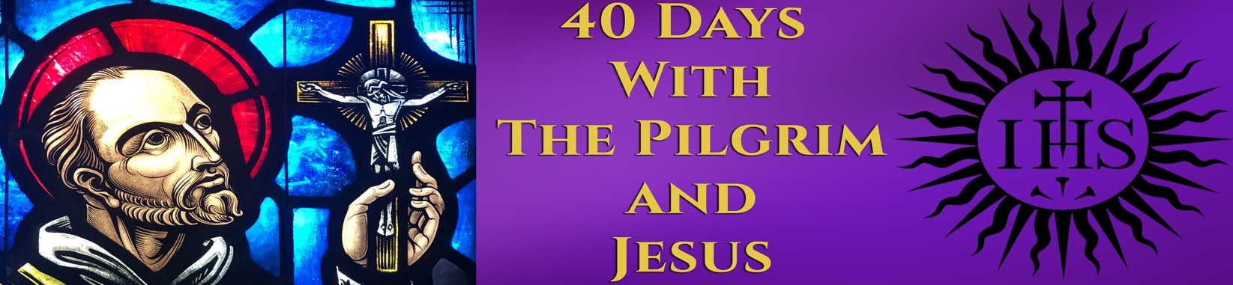
What Are the Spiritual Exercises of St Ignatius?
The Spiritual Exercises grew out of Ignatius Loyola’s personal experience as a man seeking to grow in union with God and to discern God’s will. He kept a journal as he gained spiritual insight and deepened his spiritual experience. He added to these notes as he directed other people and discovered what “worked.” Eventually Ignatius gathered these prayers, meditations, reflections, and directions into a carefully designed framework of a retreat, which he called “spiritual exercises.”
Ignatius wrote that the Exercises: “have as their purpose the conquest of self and the regulation of one’s life in such a way that no decision is made under the influence of any inordinate attachment.” He wanted individuals to undertake these exercises with the assistance of an experienced spiritual director who would help them shape the retreat and understand what they were experiencing. The book of Spiritual Exercises is a handbook to be used by the director, not by the person making the retreat.

The Structure of the Exercises
Ignatius organized the Exercises into four “weeks.” These are not seven-day weeks, but stages on a journey to spiritual freedom and wholehearted commitment to the service of God.
First week. The first week of the Exercises is a time of reflection on our lives in light of God’s boundless love for us. We see that our response to God’s love has been hindered by patterns of sin. We face these sins knowing that God wants to free us of everything that gets in the way of our loving response to him. The first week ends with a meditation on Christ’s call to follow him.
Second week. The meditations and prayers of the second week teach us how to follow Christ as his disciples. We reflect on Scripture passages: Christ’s birth and baptism, his sermon on the mount, his ministry of healing and teaching, his raising Lazarus from the dead. We are brought to decisions to change our lives to do Christ’s work in the world and to love him more intimately.
Third week. We meditate on Christ’s Last Supper, passion, and death. We see his suffering and the gift of the Eucharist as the ultimate expression of God’s love.
Fourth week. We meditate on Jesus’ resurrection and his apparitions to his disciples. We walk with the risen Christ and set out to love and serve him in concrete ways in our lives in the world.
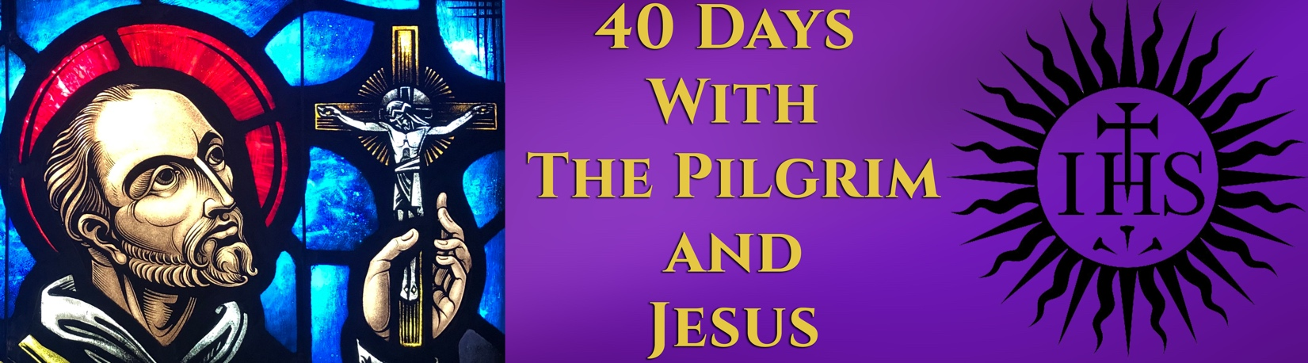
THE FIRST PRINCIPLE AND FOUNDATION
From the Spiritual Exercises [23] of Ignatius of Loyola

God created human beings to praise, reverence, and serve God, and by doing this, to save their souls.

God created all other things on the face of the earth to help fulfill this purpose.

From this it follows that we are to use the things of this world only to the extent that they help us to this end, and we ought to rid ourselves of the things of this world to the extent that they get in the way of this end.

For this it is necessary to make ourselves indifferent to all created things as much as we are able, so that we do not necessarily want health rather than sickness, riches rather than poverty, honor rather than dishonor, a long rather than a short life, and so in all the rest, so that we ultimately desire and choose only what is most conducive for us to the end for which God created us.

Prayer Is a Conversation
The underlying dynamic of Ignatian prayer is that of a conversation. We are in a relationship with God that involves give and take, our response to his invitation, a sharing of life. The Spiritual Exercises urge us to see ourselves as God sees us—as sons and daughters, members of his family. Jesus used the affectionate word abba to refer to his Father when he prayed. The closest English equivalent is “Papa.” We can address God in the same intimate way because we are his children.
Prayer is a natural outcome of this close relationship. Prayer is a conversation. The essential activity of prayer springs naturally from our humanity. It is a matter of conversing with a very good friend.
From the beginning of his spiritual journey, Ignatius had a good idea of what he wanted to do. He wanted to evangelize, to bring the good news of the Incarnation to others. He wanted to lead others into a relationship with Christ Jesus.
How to accomplish this was less clear. It took years for him to develop the attitudes, insights, and techniques that we know as Ignatian spirituality. He made many mistakes along the way and wandered down several blind alleys. He was familiar with the work of the Dominicans—an order of learned clerics who specialized in the ministry of preaching. Ignatius admired good preaching, but this was not the evangelistic tool he was looking for. Ignatius was attracted to the Franciscans, who gave a powerful witness to the gospel through their poverty. But he did not think that humble itinerant begging was the direction God wanted him to take.
Some spiritual approaches seemed too passive to him. They were based on reading books and listening to sermons and lectures. They appeared to say that God can be found through some kind of passive absorption of good will and good behavior. Ignatius practiced an active spirituality. He understood that people were actively engaged with work in the world. They had dealings with each other. They shared life with each other. This active sharing of grace and gifts and talents eventually became the how for his evangelistic ministry.
Ignatius describes his ministry by the simple Spanish word conversar. Conversar means “to converse,” “to talk with.” Its simplest meaning in English is sincere talk with another person, the kind of comfortable, satisfying conversation whereby we truly get to know someone else. Ignatius must have been a master of this kind of conversation. He seems to have had an extraordinary gift for friendship.
Conversar has broader meanings as well. It means “to be conversant with” something or someone—that is, to truly know them deeply. It means “to have dealings with.” To converse with someone is to know them and to be involved with their lives. In the Ignatian scheme of things, to converse is one of our ways of loving.
Ignatius’s spiritual life developed around the idea of conversation. It is based on conversation with God in prayer. It is developed through conversation with others—spiritual directors, confessors, like-minded friends who share one’s ideals and way of life. It is expressed in conversation as ministry—sharing the gospel with others. All three conversations are embodied in the Spiritual Exercises. The retreatant is guided through the exercises by conversation with a spiritual director who cultivates the conversation with God. The exercises nurture a conversation with God. The goal of the Exercises is to help the person get involved in a more fruitful conversation with others in ministry.
In fact, the Exercises themselves are the product of years of conversation. Ignatius developed them from his experience as a spiritual director of men and women seeking a deeper relationship with God. He would suggest ways to pray, scripture passages to meditate on, scenes to imagine, ideas to ponder. Then he and his friends would talk about what happened in prayer. Together they would discern how God seemed to be leading. Ignatius’s book, perhaps the most influential book ever written about developing our relationship with God, is essentially a collection of these exercises, sharpened and honed in conversation.

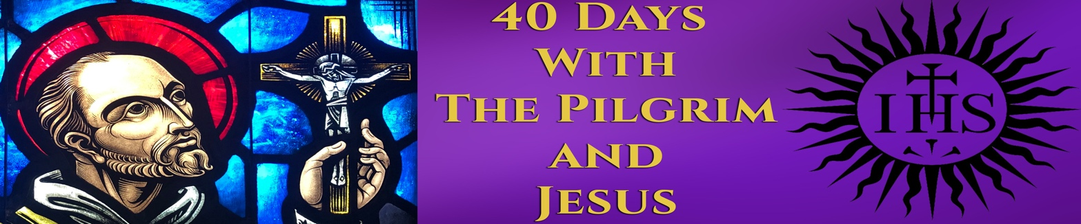
Prayer in the Spiritual Exercises
The two primary forms of praying taught in the Exercises are meditation and contemplation. In meditation, we use our minds. We ponder the basic principles that guide our life. We pray over words, images, and ideas.
Contemplation is more about feeling than thinking. Contemplation often stirs the emotions and enkindles deep desires. In contemplation, we rely on our imaginations to place ourselves in a setting from the Gospels or in a scene proposed by Ignatius. We pray with Scripture. We do not study it.
St Ignatius of Loyola was convinced that God can speak to us as surely through our imagination as through our thoughts and memories. In the Ignatian tradition, praying with the imagination is called contemplation. In the Spiritual Exercises, contemplation is a very active way of praying that engages the mind and heart and stirs up thoughts and emotions. (Note that in other spiritual traditions, contemplation has quite a different meaning: it refers to a way of praying that frees the mind of all thoughts and images.)
Ignatian contemplation is suited especially for the Gospels. Beginning in the Second Week of the Exercises, it is possible to accompany Jesus through his life by imagining scenes from the Gospel stories. This type of prayer allows the events of Jesus’ life be present in our own worlds. The prayer encourages visualization of the Gospel events as if you were making a movie. Attention is paid to the details: sights, sounds, tastes, smells, and feelings of the event. Participants are asked to lose themselves in the story, allowing the imagination to run with it-- placing themselves in the scene.
Contemplating a Gospel scene is not simply remembering it or going back in time. Through the act of contemplation, the Holy Spirit makes present a mystery of Jesus’ life in a way that is meaningful for you now. Imagination is used to dig deeper into the story so that God may communicate with you in a personal, evocative way.
The discernment of spirits underlies the Exercises. We notice the interior movements of our hearts, and discern where they are leading us. A regular practice of discernment helps us make good decisions.

THE IGNATIAN EXAMEN

One of the most beautiful ways you can nourish your relationship with God is to participate in the Examen, a form of prayer given to us by Saint Ignatius. The Examen is a daily examination of conscience that invites you to reflect on your day. The purpose is to become more aware of the ways in which God has been present to you and to recognize where the Spirit is urging you to strengthen and grow. The Examen traditionally has five steps:

Resting in God's presence
Begin by taking a few moments to quiet yourself. Remember that you are in God's presence. No matter where you are, you are in the midst of God's creation, and the presence and love of God surrounds you.

Giving thanks
Remember the gifts of the day-those times of contentment or joy or simple pleasures. Thank God for these gifts. Be concrete! Recall the taste of a strawberry, a walk with a friend, an unexpected kindness or thoughtful gesture. Then thank God for the permanent gifts you have been given­ your own particular strengths or talents that help you live your life.

Examining the day
Before reflecting on the events of the day, ask the Holy Spirit to be with you and to guide you so that you can look back at the events and experience of the day with honesty and an open heart. Reflect on the people you encountered and your response to them. Think over the needs that they may have expressed. Consider the way you reacted to any problems or concerns.

Try to recognize these as invitations from God to deepen your relationship with him and with others.

Asking for healing
Look back on the day for ways in which you failed to respond or to take action in love for God and for others. You may recognize that the day left little time for you to be aware of God's presence in the people and creation around you. Bring these times to God, not for judgment but for healing.

Trusting in the Spirit's guidance
Conclude by asking God's blessings on the next day. Trust that the Spirit will guide and enlighten you.

PREPARING FOR THE RETREAT
Before beginning the Spiritual Exercises of St Ignatius of Loyola, you must carefully discern whether you're ready for the adventure and in what way you will travel. Retreatants should already be in the habit of praying and are comfortable talking about their interior Iife and their faith with a spiritual director or group.

Ignatius offers some helpful advice to prepare for the adventure. We are wise to follow his counsel. His suggestions will help you develop a rhythm and pace of prayer, which you can adjust and personalize as you progress in whatever retreat form you've chosen.

First, commit to spending thirty to forty-five minutes per day in private, personal prayer. You need an extended period of time to engage the prayer material deeply and savor the graces offered. To help you establish a habit of praying during the retreat, try praying at the same time each day. Find a regular prayer space: a quiet room in your home with a comfortable chair, a favorite church or chapel, even a place outside. It is possible to pray even while walking in a park, or in the midst of a crowded city.
It can be helpful to keep the same prayer space during the retreat. Such regularity can be helpful in getting you into the prayer. To remind you that the space is sacred, you can mark it with a candle, icon, crucifix. Sometimes using incense or even light non-distracting music can be helpful.

As your retreat director, I’ll be offering you material to pray over: Scripture passages, Ignatius’s meditations and contemplations, or other readings and exercises. Look over these materials before you formally begin your prayer—either in the evening or morning before you pray.

This preparation allows you to sort through any questions or confusion about the prayer material itself, thus removing unnecessary mental clutter from your prayer period. That way you can dive right in when you go to your prayer space.

In the time immediately before your prayer period, avoid sensory or information overload. Turn off the television and radio and news sources; don't check e-mail or browse the Internet; turn off your cell phone. This discipline will make transitioning into the quiet of prayer easier.

In addition to structuring your day and your enviro.ment, you will benefit by ordering, at least at first, your time of prayer (or "prayer period"):

Compose Yourself

Ignatius writes:

“A step or two away from the place where I will make my contemplation or meditation, I will stand for the length of an Our Father. I will raise my mind and think how God our Lord is looking at me, and other such thoughts. Then I will make an act of reverence or humility.”

- Imagine how God looks upon you: with great joy and gratitude for your offering of time. Imagine God's long, loving gaze upon you.

- Once you are in your prayer space, still yourself. Although it is sometimes hard to settle your mind, you can relax your body by breathing deeply and slowly. With each breath, you may utter a short mantra, such as "God be with me," "My Lord and my God,""Come, Holy Spirit," or something similar.

- In prayer, the body and spirit work together. Find a posture conducive to prayer: sit, kneel, stand, or recline in a relaxed position (SE 76). Finding a comfortable posture will keep you from changing it as you pray, which can be distracting. Also, beware that you are not so relaxed that you fall asleep!

- Ask God to be with you in this time of prayer. In words that flow naturally, make a simple offering of your time, atten­tion, and energies. For example, Ignatius suggests one such preparatory prayer:

“Ask God our Lord for the grace that all my intentions, actions, and operations may be ordered purely to the service and praise of the Divine Majesty.”

- In making the offering, you remind yourself at the outset that you are not thinking about God but encountering God in a very real way.

Pray for the Grace

Recall from Ignatius's conversion story how God gently but steadily transformed his zeal and passion from serving the king and winning the love of a lady to serving the church for the greater glory of God. Ignatian spirituality taps into our deepest desires. In them we can discern God's noble desires for us.

Thus, at the beginning of each prayer period, Ignatius advises that we pray for a certain grace, or gift from God: "ask God our Lord for what I want and desire". Simply naming what we deeply desire opens us to receive the gift God wants to give us. Moreover, praying for a grace helps us to notice when we actually receive that gift later on. In this way, we realize that the grace is not of our own making but is the result of God's generosity to us. Finally, praying out of our desires grounds us in the present, keeping our prayer "real."

Throughout the retreat, Ignatius suggests specific graces to pray for. Always feel free to articulate a different grace or to use different words if the Spirit is moving you in that direction. Imagine God asking you, "What do you want me to do for you?"

Some graces are hard to ask for. For example, in all honesty, you may resist asking to let go of a preoccupation or way of thinking or acting that is comfortable for you. Or you may hesitate in asking to be placed with Christ, carrying the cross. Such resistance is understandable. If you find yourself resisting a suggested grace, then pray not for the grace itself but for a desire to want the grace. For example, "Lord, I'm really having a hard time asking to walk with you by living a more simple life; for now, give me the desire to want to do that."

Although grace is revealed in the particular gifts God gives you, grace above all is God's presence in your life. The Giver is the gift!

Do the Prayer

Having taken some time to compose yourself and center your mind and heart, engage the material that I suggest as your spiritual director. I’ll be giving you alternative materials. Don't worry about using them all or missing something if you skip around. God will give you what you need!

Ignatius give you room to adapt the Exercises to meet you where you are, emotionally and spiritually, during the retreat. This flexibility is especially important if you are doing a shorter version of the Exercises (8 days versus 30 days), when some person, problem, or experience may become the focus of your prayer or when you spend several prayer periods lingering over one meditation or contemplation.

Close Your Prayer

Just as you begin your prayer time with certain rituals or prayers, you should formally bring your prayer to a close. You can conclude with a favorite prayer, such as the Our Father or Hail Mary, or with another prayer of your choosing. You might spontaneously pray to God the Father, to Jesus, or to Mary in a very conversational manner. Use your body to mark the closing of prayer: such as with a bow, by making the sign of the cross, or with an open gesture of the hands or arms.

Review the Prayer

Ignatius advises that after we formally close our prayer, we reflect on our experience of prayer. Keeping a journal is most helpful during a retreat. This exercise can be challenging because we are trying to put into words our encounter with God, who is Holy Mystery. Although it is challenging, trying to articulate such sublime experiences can help us discern how God is meeting us or leading us in our prayer. As a practical matter, journaling helps you prepare for meetings with me as your spiritual director. The journal is for your eyes only. When the retreat concludes, the journal becomes a rich spiritual treasure to which you can return months or even years after the retreat.

The purpose of journaling is not to replay your time of prayer minute by minute. Instead, after your prayer period concludes, consider the following:

- What were the significant interior movements (that is, feelings, reactions, intuitions, desires, emotions, thoughts, or insights)?
- What was the prevailing mood of my prayer: peace, agitation, excitement, boredom, confusion, calm?
- Was my prayer more about the head or the heart, or about both?
- What word, phrase, image, or memory meant most to me during prayer?
- Is there some unfinished business that I think God is calling me to return to during another time of prayer?
- Is there something happening in my life that is becoming part of my prayer? Do I feel moved to do something con­crete in my life?
- Am I making the necessary preparations for my prayer? Is there anything I am doing or not doing that is getting in the way of my listening to God?

The review of prayer is not homework; do not feel bound to answer each of these questions every time you journal. Instead, consider journaling as another way of praying, of going deeper to sift through the graces. Write in a style that is comfortable for you. In your journaling, feel free to write directly to God the Father or to Jesus, as if you were writing a letter or an e-mail.

All of these guidelines reflect the wisdom of St. Ignatius and retreat directors who are committed to Ignatian ways of praying. However helpful they may be, the guidelines are not a magic formula that will automatically summon certain graces. We cannot control the movement of God in our lives, but we can take concrete steps to make ourselves more open and receptive to how God speaks to us.

WK 1 PRAYER:
GRATITUDE PRAYER FOR GOD’S UNCONDITIONAL LOVE FOR ME

You are encouraged to consider who you are—or rather, whose you are. Each one of us is God’s beloved daughter or son: this is the core of our identity.

It is suggested that you use the following Scripture passages in your prayer. Do not feel that you need to run through them like homework. Follow the lead of the Spirit to help you discern which passages to use and perhaps repeat. You may wish to pray with one of the passages multiple times during the week.

At the beginning of each prayer period, pray for the grace to be more aware of how near God is to you, and how deeply he loves you and blesses you every day in your life: the gifts of your family members; your friends and neighbors; your material possessions and home; your job; your personal gifts that you have been given to share with others. Pray that you trust God’s unconditional love for you.

Clear your mind and heart of everything before you begin to pray, and then allow God to speak through each Scripture passage. I suggest that you read the Scripture passages carefully once. Stay quiet for some moments. Then read the passage slowly and carefully again. A sentence, a phrase, or even a word might rise out of the passage. It may evoke thoughts of someone or some moment in your life. It may bring to mind some images from your life. Follow them—God may want to speak to you through these thoughts. Allow the connections to be made, spend some time in this reflection/contemplation.

At the end of your prayer time, review the graces that God has communicated to you. Thank God for them. I suggest it is helpful that you make note of the results of this prayer—perhaps by writing (briefly, longer if necessary) in a journal.

Read Psalm 131 I have calmed and quieted my soul. How can I simply rest in God during my prayer—no work involved, just being with God?

Read Isaiah 43:1-7. I have called you by name. You are mine. Who is God for me? How does God see me?

Read Psalm 139: 1-18. You have searched me and you know me. How can I possibly escape the love of God?

Read Luke 12:22-34 God cares for you as the lilies of the field. What worries or fears do I want God to help me let go of?

Read Psalm 23 The Lord is my shepherd. How is the Lord with me when I am lost and need to be found?

Read John 11:28-37. Jesus wept. When has Jesus been with me when I have been lowest? How has he wept with me?

